BIODATA

MANOJIT SIL 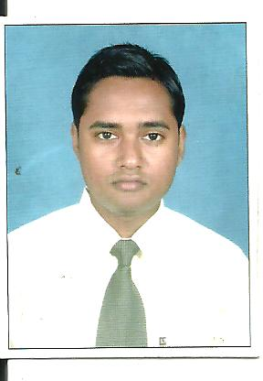

ADDRESS :-
S.V Road, Birati, Sardar para,

Kolkata – 700051
E mail ID – manojitjob198586@yahoo.in Cont. no. – (M) 9051273527

-:ACADEMIC QUALIFICATION:-

NAME OF EXAM | BOARD \ COUNCIL\ UNIVERSITY | YEAR OF PASSING | % OF MARK
MADHAMIK | W.B.B.S.E | 2002 | 56 %
H.S | W.B.C.H.S.E | 2004 | 37 %
B.COM | C.U | 2008 | 43.40%

ADDITIONAL QUALIFICATION:-

Basic of computer (Internet, Ms.word, Ms.powerpoint, Ms. excel & E-mail) from Youth
computer training institute (Moulali Yuva Kendra).
Financial Accounting from Brainware computer academy.

WORK EXPERIENCE:-

- Worked as a Student relation officer in Brainware Consultency Pvt.ltd. from 10-02-2010 to 10-07-2010. (Responsibility: Maintain stock of stationary, dill with vendors, etc.)
- Worked at G I Security Pvt. Ltd. as an Admin assistant. From 12-07-2010 to 17-02-2013.
- Now working at Wishnet Pvt. Ltd. as an Admin Executive. From 21-02-2013 to till date.

WORK RESPONSIBILITY:-

- Look after of Pay direct card distribution.
- Look after of all AMC.
- Doing joining formalities of staffs. (Fill up joining form as per company’s norms, Document verification, Reference check)
- Arrange interview.
- Employee turnover of all branches.
- Employee grievance redressing.
- Employee retention.
- Ensure timely confirmation.
- Make staff attendance from biometric machine.
- Put duty schedule of all staff at biometric machine.(As per shift)
- Responsible for leave. (Leave calculation as per company’s leave policy)
- Responsible for Printing & stationary,
- Make offer latter and appointment latter.
- Generate and distribution of monthly pay-slips.
- Assist in recruitment process.
- Provide ID card.
- Provide visiting card.
- Store handling.
- Responsible for mobile bill.
- Responsible for Holiday duty calculation.
- Responsible for documentation and MIS.
- Exit report; etc.

PERSONAL DETAILS :-

Father’s Name : Sri Manoj Kumar Sil.

Date of Birth : 27th October 1985.

Marital Status : Married
Sex : Male.
Nationality : Indian.
Religion : Hindu.
Language Known : English, Bengali, and Hindi.

Date: Signature

